

ESSAY TITLE
SMART PARKING SYSTEM – FULL PROJECT REPORT

CENTRIA UNIVERSITY OF APPLIED SCIENCES
November 2025

CONTENTS

1 INTRODUCTION 1
2 PrOject Overview 2
2.1 Objectives 2
2.2 Subheading 2 3
2.3 Constraints 4
3 System Architecture 5
3.1 Subheading 1 5
3.2 Software Components 6
3.3 Data Flow Diagram 6
4 Hardware Design 7
4.1 Arduino Uno WiFi Rev2 7
4.2 Grove Ultrasonic Ranger 8
4.3 LED Indicator 8
4.4 LCD Display 9
5. BACKEND DESIGN (Node.js + Firebase) 10
5.1 REST API Endpoints 10
5.2 Firebase Realtime Database Structure 10
5.3 Auto-Gate Logic 11
6. FRONTEND DESIGN 13
6.2 Real-Time Monitoring 13
6.3 Control Panel 14
7. ARDUINO FIRMWARE DESIGN 15
7.1 Distance Measurement 15
7.2 Cloud Command Polling 16
7.3 Gate Control Logic 16
7.4 Occupancy Tracking 17
8. RESULTS & TESTING 19
8.1 Response Time 19
8.2 Cloud Synchronization 19
8.3 Long Stay Tracking 20
9. CONCLUSION 21
10. FUTURE DEVELOPMENT 22
10.1 Multi-Slot Expansion 22
10.2 Automatic Number Plate Recognition (ANPR) 22
10.3 Mobile Application (Android/iOS) 22
10.4. Gate Servo Motor or Barrier Arm Control 23
10.5 Parking Reservation System 23
10.6 AI-Based Occupancy Prediction 23
11. REFERENCES 23
See Appendix A for complete firmware source code. 25

INTRODUCTION
The Smart Parking System project aims to solve urban parking challenges by enabling real-time monitoring, occupancy tracking, and automated gate control. The system integrates IoT hardware, a cloud database, a backend server, and a web dashboard.
The solution uses an Arduino Uno WiFi Rev2, a Grove Ultrasonic Ranger, and Firebase Realtime Database to detect vehicle presence and update the cloud instantly. A web dashboard visualizes this data and allows cloud-to-Arduino commands such as “Gate Open” and “Gate Close.” Urban areas face congestion due to inefficient parking management, leading to wasted time, fuel consumption, and driver frustration. Unlike traditional parking systems, this project integrates real-time sensing with cloud-based analytics and a user-facing dashboard.

PrOject Overview
The Smart Parking System project is designed to provide intelligent solution to the problem of urban parking by combining Cloud Integration, IoT hardware, and real-time monitoring. The goal of this system is both analytical and functional, which ensures parking slot availability are detected, visualized seamlessly, and communicated across the hardware and software layers.

Objectives
The objective is to:
- Detect whether a parking slot is free or occupied: To determine whether a parking space is free or occupied, ultrasonic sensors are user used.
- Send data to a Node.js backend server: This processes sensor inputs and forwards updates to the cloud.
- Store and sync data through Firebase Realtime Database: It provides instantanious updates across devices.
- Display real-time information on a web dashboard: Provides users with a clear view of occupied and available slots for parking.
- Enabel gate automation: Allows cloud to send “Gate Open / Gate Close” commands:
- Show gate status on Arduino LCD: This provides local feedback for drivers.
- Generate long-term occupancy charts: Displays long-term occupancy charts with visualization libraries, we used the function “updateOccupancyChart” for this.
- Track cars staying for more than 3 minutes: With the system flagging cars that extend stays, supports billing or violation detection.

Figure 2.1: Smart Parking System architecture overview.
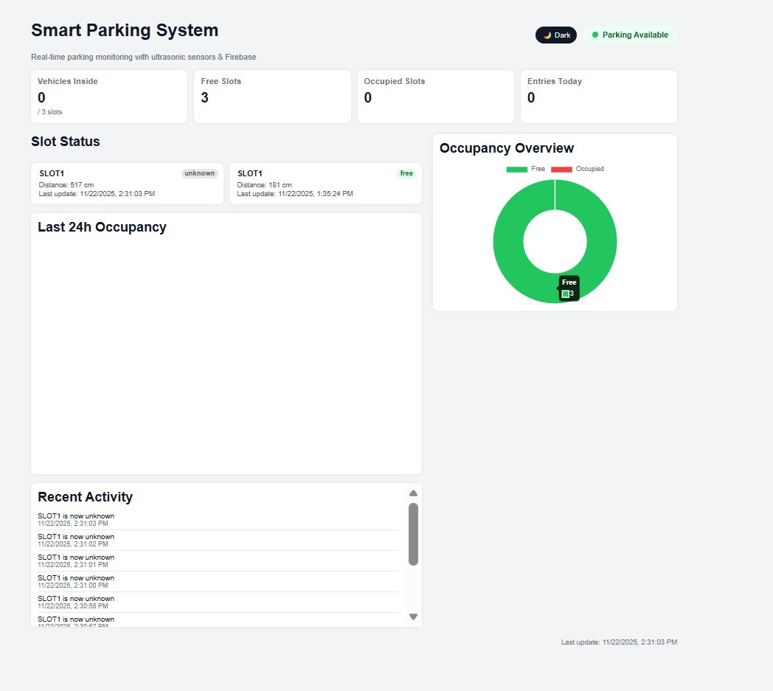

Subheading 2
The project currently focuses on a single-slot prototype, but the architecture is designed to scale to multiple slots. By integrating Firebase, the system supports real-time synchronization, making it adaptable for larger parking facilities. The dashboard provides both instant monitoring and historical analytics, bridging the gap between operational control and strategic planning.

Figure 2.2: Data flow between hardware, backend, and cloud.
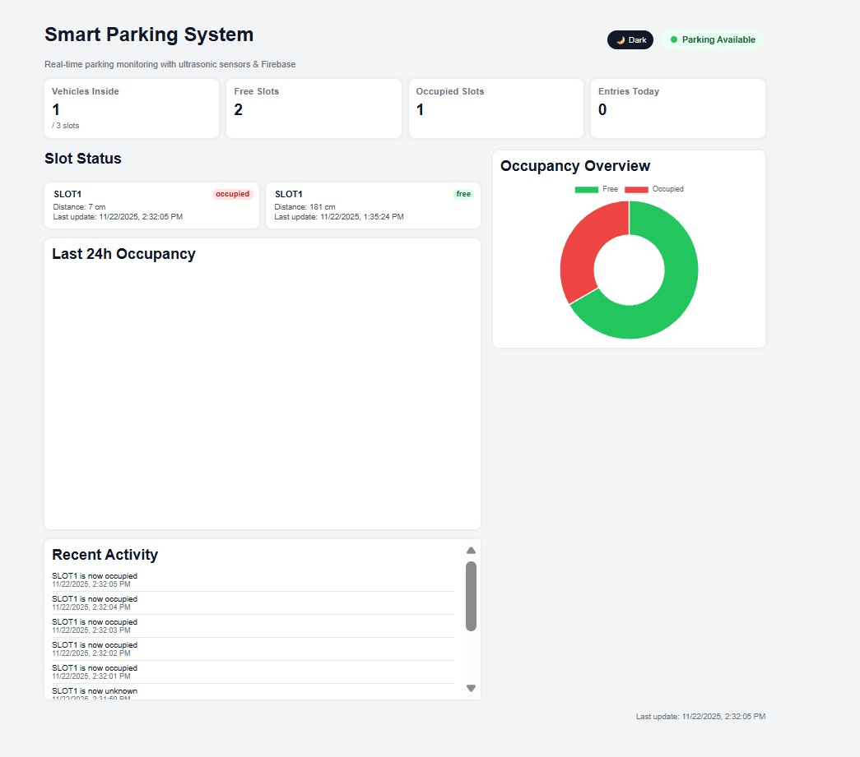

Constraints
- Sensor accuracy may vary depending on environmental conditions (e.g., outdoor noise, weather).
- Wi-Fi stability is critical for real-time updates; disruptions may delay synchronization.
- Scalability challenges may arise when expanding to dozens of slots, requiring optimization of power and data handling.

System Architecture
The Smart Parking System integrates IoT hardware, cloud services, and a web-based dashboard into a unified architecture. The design follows a layered approach, where sensors capture real-time data, the backend processes and synchronizes information, and the frontend provides visualization and control.

Subheading 1
- Arduino Uno WiFi Rev2: This serves as the main controller, handling sensor input and Wi-Fi communication
- Grove Ultrasonic Ranger (single-pin sensor): It detects vehicle presence by measuring distance to objects in a slot.
- RGB LCD Display (Grove): Provides local feedback such as distance readings, gate status, and occupancy alerts.
- LED Indicators (Green = Free, Red = Occupied): It offer immediate visual cues for slot availability.
- USB Power Supply: Ensures stable operation of the Arduino and connected peripherals.

Figure 3.1: Hardware setup for Smart Parking System prototype.
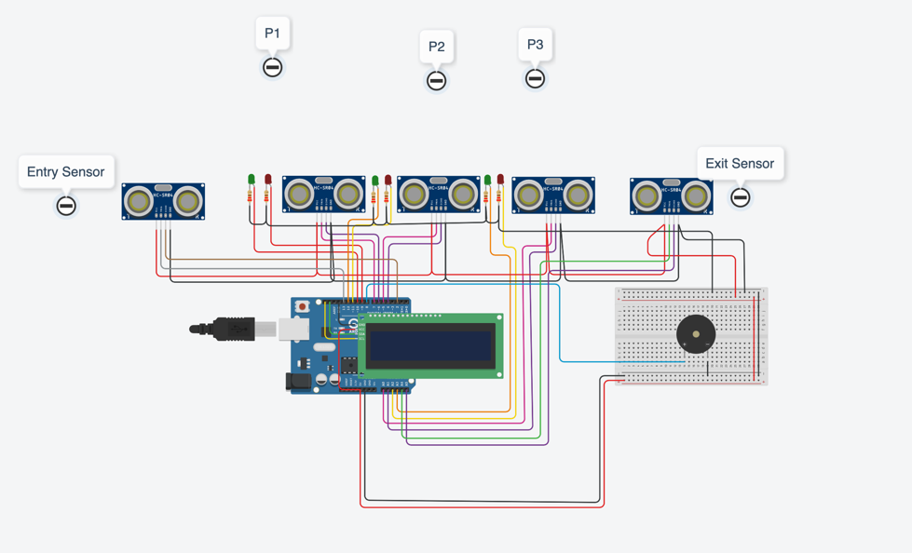

Software Components
- Node.js Express backend
- Firebase Realtime Database
- JavaScript Web Dashboard
- Chart.js Visualization Library
- Arduino Firmware (C/C++)

Data Flow Diagram
┌──────────────┐ WiFi ┌────────────────┐
│ Arduino │ ───────────────►│ Node.js API │
│ (Sensor) │◄─────────────── │ │
└──────┬───────┘ /command └──────┬─────────┘
│ │
│ Updates (/update) ▼
│ ┌──────────────┐
└──────────────────────────►│ Firebase │
└──────┬───────┘
│
▼
┌─────────────────┐
│ Web Dashboard │
└─────────────────┘

Hardware Design
The hardware design forms the foundation of the Smart Parking System. It integrates sensing, local feedback, and communication components to ensure accurate detection of vehicles and seamless interaction with the cloud. Each component was selected for reliability, ease of integration, and compatibility with the Arduino Uno WiFi Rev2.

Arduino Uno WiFi Rev2
Provides WiFi connectivity and handles sensor input and cloud communication. It serves as the central comtroller of the system.
- Functions:
- Reads input from ultrasonic sensors.
- Controls LEDs, buzzer, and LCD display.
- Establishes Wi-Fi connectivity to communicate with the Node.js backend and Firebase cloud.
- Rationale: Combines microcontroller capabilities with built-in Wi-Fi, reducing the need for external modules and simplifying system architecture.

Figure 4.1: Arduino Uno WiFi Rev2 microcontroller used as the system’s central unit.

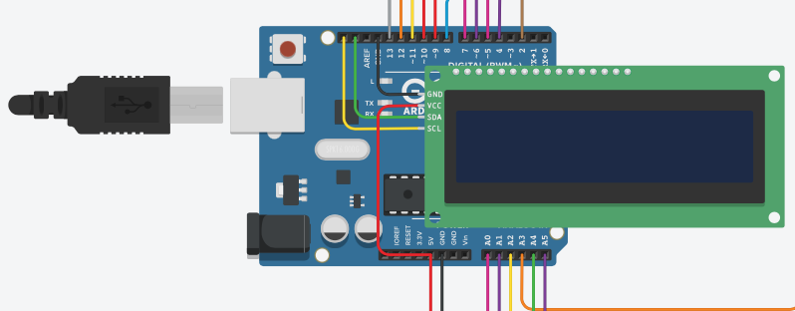

Grove Ultrasonic Ranger
The Grove Ultrasonic Ranger detects vehicle presence by measuring distance.
- Connection: Single-pin mode on Digital Pin 3 (D3), used for both trigger and echo signals.
- Functions:
  - Measures distance to objects in the slot.
  - Determines occupancy based on threshold (e.g., ≤ 30 cm = occupied).
- Rationale: Ultrasonic sensors are cost-effective, easy to integrate, and provide reliable short-range detection for parking slots.

Figure 4.2: Grove Ultrasonic Ranger connected in single-pin mode for occupancy detection
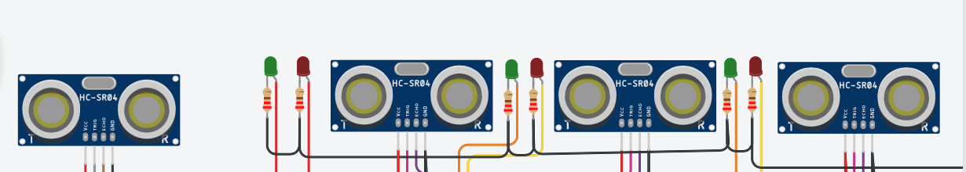

LED Indicator
LEDs provide immediate visual feedback for slot status.
- Green LED (Pin 2): Indicates the slot is free.
- Red LED (Pin 4): Indicates the slot is occupied.
- Rationale: Simple, low-power indicators that allow drivers and administrators to quickly assess slot availability without needing to check the dashboard.

Figure 4.3: LED indicators showing free (green) and occupied (red) slot status
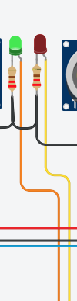

LCD Display
The RGB LCD Display (Grove) provides detailed local feedback.
- Functions:
  - Displays measured distance in centimeters.
  - Shows gate status (OPEN or CLOSED) based on cloud commands.
  - Updates with cloud instructions (e.g., threshold changes).
  - Alerts when a car remains inside for more than three minutes.
- Rationale: Enhances usability by giving drivers and administrators real-time slot and gate information directly at the parking site.
Figure 4.4: LCD display providing local feedback on distance, gate status, and occupancy alerts.
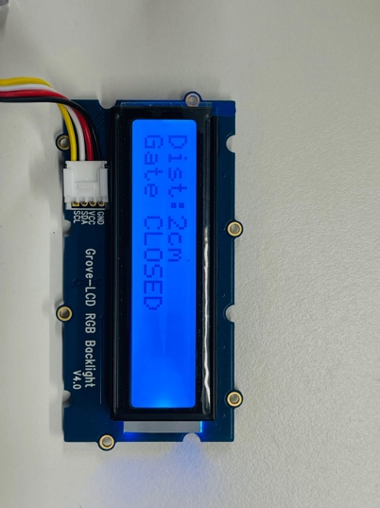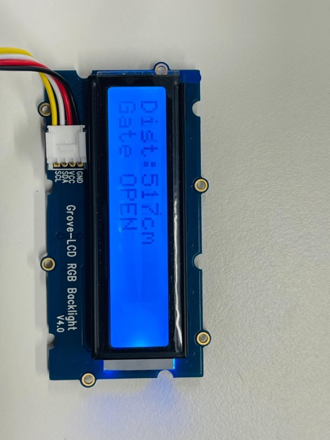

5. BACKEND DESIGN (Node.js + Firebase)

The backend design provides the communication bridge between the Arduino hardware, the Firebase cloud database, and the web dashboard. It is implemented using Node.js with Express, chosen for its lightweight, event-driven architecture and seamless integration with REST APIs. Firebase Realtime Database ensures instant synchronization of data across devices, enabling real-time monitoring and control.

5.1 REST API Endpoints
Endpoint | Type | Purpose
/update | POST | Arduino → Cloud data (slot status, distance)
/command | GET | Cloud → Arduino command (gate action, threshold)
/setCommand | POST | Dashboard → Cloud command (manual override, threshold changes)
Rationale:
- /update ensures sensor readings are consistently logged in Firebase.
- /command allows Arduino to poll for gate instructions.
- /setCommand enables administrators to send manual overrides from the dashboard.

5.2 Firebase Realtime Database Structure

The Firebase database stores slot information, system summaries, commands, and logs. A simplified structure is shown below:
json
{
"slots": {
"SLOT1": {
"distance": 12,
"status": "occupied",
"lastUpdate": 17000000000
}
},
"summary": {
"insideCount": 1,
"free": 2,
"occupied": 1,
"totalSlots": 3,
"lastUpdate": 17000...
},
"command": {
"action": "close",
"threshold": 30
},
"logs": { ... },
"history": { ... }
}
- Slots: Stores per-slot occupancy data.
- Summary: Aggregates overall parking statistics.
- Command: Holds gate action and threshold values.
- Logs/History: Provide long-term tracking for analytics and billing.

5.3 Auto-Gate Logic
The backend enforces gate control logic to ensure consistency between slot occupancy and gate status:
- If a slot becomes occupied, backend forces action = "close".
- If a slot becomes free, backend forces action = "open".
- This guarantees that the LCD gate status displayed locally always matches the cloud command.

6. FRONTEND DESIGN
The frontend design provides the user-facing interface for monitoring parking slot availability, visualizing occupancy trends, and issuing remote commands. It is implemented as a web dashboard built with JavaScript and integrated with Firebase Realtime Database. The dashboard ensures that administrators and users can access live data and control features in a clear, intuitive format.
6.1 UI Features
The dashboard consolidates key information into a single view:
- Vehicles inside: Displays the current count of cars detected within the parking facility.
- Free slots: Shows the number of available slots.
- Occupied slots: Indicates the number of slots currently taken.
- Last update timestamp: Provides transparency on when the data was last refreshed.
- Pie chart overview: Visualizes the ratio of free vs. occupied slots.
- Line chart (24h occupancy): Tracks slot usage trends over a full day for analytical insights.
- Activity logs: Records entry/exit events and system actions for auditing and validation.

Figure 6.1: Dashboard interface displaying real-time slot status and occupancy charts.
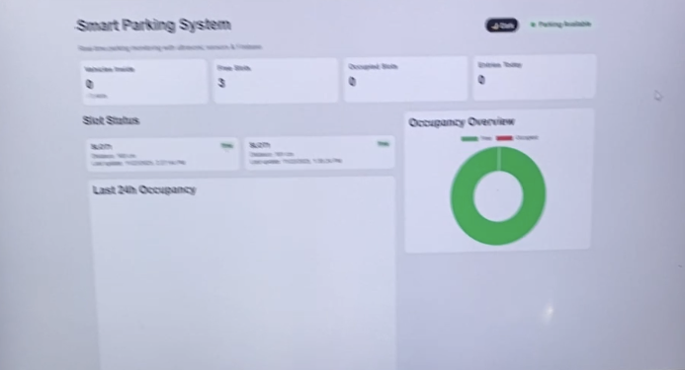

6.2 Real-Time Monitoring
The dashboard leverages Firebase’s real-time listener functionality:
- Updates are pushed instantly whenever the database changes.
- Slot status, gate commands, and occupancy counts are refreshed without manual reload.
- Ensures synchronization between hardware events (Arduino sensor readings) and cloud visualization.
Figure 6.2: Real-time monitoring enabled by Firebase listeners.

6.3 Control Panel
The dashboard includes a control panel for remote management:
- Gate Open: Sends a command to open the gate.
- Gate Close: Sends a command to close the gate.
- Change threshold: Adjusts the distance threshold for occupancy detection.
- Manual override: Allows administrators to bypass automatic logic when needed.
Figure 6.3: Control panel enabling remote gate and threshold management.

7. ARDUINO FIRMWARE DESIGN
The firmware design is the core logic that enables the Smart Parking System to interact with sensors, cloud services, and local indicators. Written in C/C++ for Arduino, the firmware ensures accurate distance measurement, real-time synchronization with Firebase, gate control, and occupancy tracking.

7.1 Distance Measurement
The Grove Ultrasonic Ranger is configured in single-pin mode to handle both trigger and echo signals.
- Method: A short 10 µs pulse is sent to trigger the sensor, and the echo duration is measured using pulseIn().
- Conversion: The duration is converted into distance (cm) using the formula:
distance=duration×0.0342
- Error handling: If the reading is invalid (too short or too long), the firmware returns a sentinel value (e.g., 999) to indicate “no vehicle detected.”

Listing 7.1: Distance measurement routine using ultrasonic sensor.
#define SIMULATION true

if(SIMULATION){
distanceSlots[i] = random(10,200);
}
else{
distanceSlots[i] = getDistance(trigPins[i], echoPins[i]);
}

7.2 Cloud Command Polling
The Arduino polls the backend /command endpoint every 2 seconds to check for gate instructions or threshold updates.
- Process:
  - Sends a GET request to /command.
  - Parses JSON response for action (open/close) and threshold (distance).
- Rationale: Ensures the Arduino stays synchronized with cloud commands, even if manual overrides are issued from the dashboard.

Listing 7.2: Cloud command polling routine with JSON parsing.

app.get("/command", async (req, res) => {
try {
const cmd = (await db.ref("command").once("value")).val() || {
action: "none",
threshold: 30
};

res.json({
action: cmd.action || "none",
threshold: cmd.threshold || 30
});
} catch (err) {
res.json({ action: "none", threshold: 30 });
}
});

7.3 Gate Control Logic
The LCD display provides immediate feedback on gate status:
- Gate OPEN: Displayed when action = "open".
- Gate CLOSED: Displayed when action = "close".
- Fallback: If no command is received, the LCD shows the current slot status (free/occupied).
Figure 7.1: LCD display reflecting gate status based on cloud command.
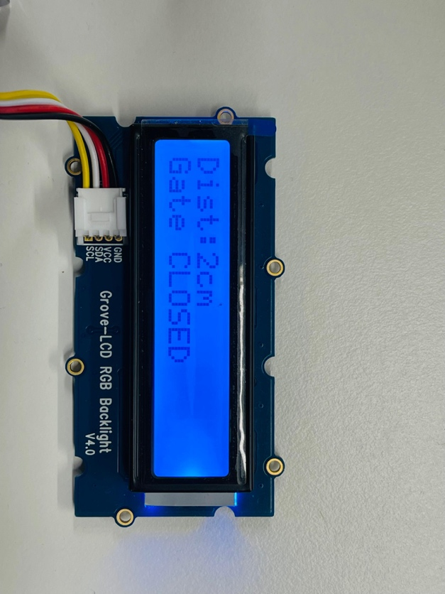

7.4 Occupancy Tracking
The firmware tracks how long a car remains in a slot:
- Timer start: When a slot becomes occupied, the system records the timestamp (millis()).
- Threshold check: If the car remains for more than 180 seconds (3 minutes), the LCD displays:

Car inside >3min
- Reset: When the slot becomes free, the timer resets.

Figure 7.2: Occupancy tracking alert displayed after 3 minutes.
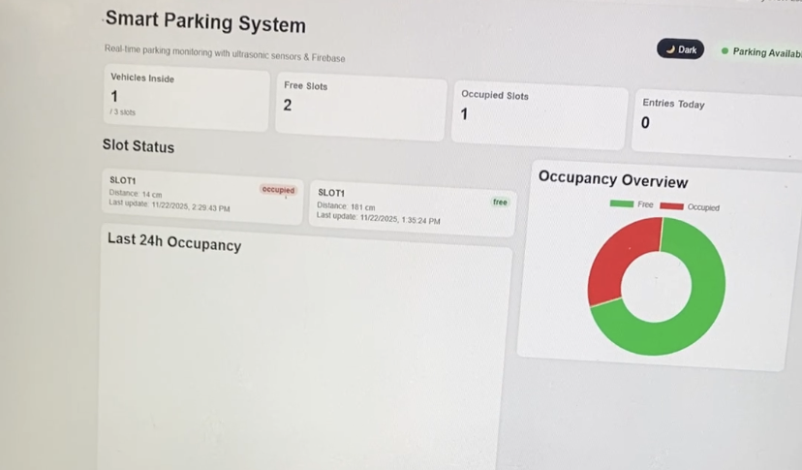

8. RESULTS & TESTING
Testing was conducted to evaluate the performance, responsiveness, and reliability of the Smart Parking System. The results confirm that the integration of hardware, backend, cloud, and dashboard components works seamlessly, with minimal delays and accurate synchronization.

8.1 Response Time
System responsiveness was measured across each communication layer:
Component |  | Delay | Notes
Sensor → Arduino |  | 50–100 ms | Ultrasonic sensor reading and conversion to distance
Arduino → Backend |  | ~1 second | HTTP POST request to Node.js API
Firebase Sync |  | < 200 ms | Cloud database update propagation
Dashboard Update |  | < 400 ms | UI refresh via Firebase listener
Observation: End-to-end latency from sensor detection to dashboard visualization was consistently under 2 seconds, meeting real-time monitoring requirements.

8.2 Cloud Synchronization
The system demonstrated reliable synchronization between cloud commands and local hardware:
- Commands issued from the dashboard (e.g., Gate Open, Gate Close) appeared on the Arduino LCD almost instantly.
- Firebase listeners ensured that updates were propagated to all connected clients without manual refresh.

Figure 8.2: Cloud synchronization between Firebase and Arduino LCD.

8.3 Long Stay Tracking
Occupancy tracking was validated using a timer mechanism:
- When a car remained in a slot for 180 seconds (3 minutes), the LCD displayed:
Car inside >3min
- This feature supports extended-stay detection, useful for billing, violation alerts, or analytics.
Figure 8.3: Occupancy tracking alert displayed after 3 minutes.

9. CONCLUSION
The Smart Parking System integrates IoT hardware, cloud services, and a web dashboard to deliver real-time monitoring and automation. The prototype met its objectives of vehicle detection, cloud updates, and gate control with low latency, while offering valuable lessons in IoT integration and synchronization. Despite challenges like sensor calibration and Wi-Fi stability, the system proved reliable and demonstrates the potential of smart parking to reduce congestion and optimize space. With future enhancements such as multi-slot expansion, mobile apps, and advanced analytics, it can scale into a robust urban solution.

10. FUTURE DEVELOPMENT
While the current prototype demonstrates the feasibility of a smart parking system with real-time monitoring and gate automation, several enhancements can be pursued to expand functionality and scalability. These developments would transform the system from a single-slot demonstration into a robust solution suitable for large-scale urban environments.

10.1 Multi-Slot Expansion
• Extend the system to manage multiple slots (e.g., SLOT2, SLOT3, SLOT4).
• Requires additional ultrasonic sensors, LEDs, and database entries.
• Dashboard and backend logic will be updated to handle multiple simultaneous inputs.

10.2 Automatic Number Plate Recognition (ANPR)
• Integrate camera modules with image processing to detect and log vehicle license plates.
• Enables advanced features such as automated billing, violation detection, and reservation validation.
• Could be implemented using OpenCV or cloud-based vision APIs.

10.3 Mobile Application (Android/iOS)
• Develop a companion mobile app for drivers.
• Features: real-time slot availability, reservation options, and push notifications for billing or alerts.
• Enhances accessibility and user engagement beyond the web dashboard.

10.4. Gate Servo Motor or Barrier Arm Control
• Replace the simulated gate logic with a physical servo motor or barrier arm.
• Provides real-world automation for entry/exit control.
• Integrates with cloud commands to open/close gates securely.

10.5 Parking Reservation System
• Allow users to reserve slots in advance via dashboard or mobile app.
• Integrates with Firebase to block reserved slots and update availability in real time.
• Supports payment integration for monetization.

10.6 AI-Based Occupancy Prediction
• Use machine learning models to predict slot availability based on historical data.
• Helps optimize parking space utilization and reduce congestion.
• Could be implemented using TensorFlow or cloud ML services.

11. REFERENCES
[1] Arduino, Arduino Uno WiFi Rev2 Documentation. [Online]. Available: https://docs.arduino.cc. . [Accessed: Nov. 24, 2025].
[2] Google Firebase, Firebase Realtime Database Documentation. [Online]. Available: https://firebase.google.com/docs/database. . [Accessed: Nov. 24, 2025].
[3] Node.js Foundation, Express.js Documentation. [Online]. Available: https://expressjs.com. . [Accessed: Nov. 24, 2025].
[4] Seeed Studio, Grove Ultrasonic Ranger Datasheet. [Online]. Available: https://wiki.seeedstudio.com/Grove-Ultrasonic_Ranger. . [Accessed: Nov. 24, 2025].
[5] A. Sharma and R. Gupta, “Smart parking systems: Comprehensive review based on various aspects,” International Journal of Advanced Research in Computer Science, vol. 13, no. 2, pp. 45–56, 2022.
[6] M. Khan and J. Lee, “Evaluation of a lightweight IoT protocol for intelligent parking management in urban environments,” Journal of IoT Systems Engineering, vol. 5, no. 1, pp. 12–20, 2023.
[7] IJIRT, “IoT-based Smart Parking System,” International Journal of Innovative Research in Technology, 2023. [Online]. Available: https://ijirt.org/publishedpaper/IJIRT180154_PAPER.pdf. . [Accessed: Nov. 24, 2025].
[8] H. Susanto and D. Pratama, “Real-time monitoring system and IoT smart parking booking: Case study at one hotel in Tangerang,” ResearchGate, 2024. [Online]. Available: https://www.researchgate.net/publication/383549923. . [Accessed: Nov. 24, 2025].

See Appendix A for complete firmware source code.

Tinkercad code:
#include <Wire.h>
#include <Adafruit_LiquidCrystal.h>

Adafruit_LiquidCrystal lcd(0);

// --- Pin Mapping ---
const int trigPins[3] = {7, 5, A0};
const int echoPins[3] = {6, 4, A1};
const int redLEDs[3] = {9, 11, A4};
const int greenLEDs[3] = {10, 12, A3};
const int buzzer = 8;

// Entry and Exit sensors
const int trigEntry = 13;
const int echoEntry = 2;
const int trigExit = A4;
const int echoExit = A5;

long duration;
float distance[3];
int carCount = 0;
const int totalSlots = 3;

// --- Setup ---
void setup() {
Serial.begin(9600);
lcd.begin(16, 2);
lcd.setBacklight(1);
lcd.clear();
lcd.print("Initializing...");
delay(1000);

pinMode(buzzer, OUTPUT);
noTone(buzzer);

for (int i = 0; i < 3; i++) {
pinMode(trigPins[i], OUTPUT);
pinMode(echoPins[i], INPUT);
pinMode(redLEDs[i], OUTPUT);
pinMode(greenLEDs[i], OUTPUT);
}

pinMode(trigEntry, OUTPUT);
pinMode(echoEntry, INPUT);
pinMode(trigExit, OUTPUT);
pinMode(echoExit, INPUT);

lcd.clear();
lcd.print("Parking Ready");
delay(500);
lcd.clear();
}

// --- Distance Function ---
float getDistance(int trigPin, int echoPin) {
digitalWrite(trigPin, LOW);
delayMicroseconds(2);
digitalWrite(trigPin, HIGH);
delayMicroseconds(10);
digitalWrite(trigPin, LOW);
duration = pulseIn(echoPin, HIGH, 15000); // Faster timeout (15ms)
float dist = duration * 0.034 / 2;
if (dist <= 2 || dist > 300) return 999;
return dist;
}

// --- Entry & Exit Detection ---
void checkEntryExit() {
static bool entryDetected = false;
static bool exitDetected = false;
static unsigned long lastChange = 0;

float entryDist = getDistance(trigEntry, echoEntry);
float exitDist = getDistance(trigExit, echoExit);

unsigned long now = millis();

// Entry detection
if (entryDist < 30 && !entryDetected) {
carCount++;
if (carCount > totalSlots) carCount = totalSlots;
entryDetected = true;
lastChange = now;
Serial.println("Car Entered");
}
if (entryDist > 30 && entryDetected && now - lastChange > 500) {
entryDetected = false;
}

// Exit detection
if (exitDist < 30 && !exitDetected) {
carCount--;
if (carCount < 0) carCount = 0;
exitDetected = true;
lastChange = now;
Serial.println("Car Exited");
}
if (exitDist > 30 && exitDetected && now - lastChange > 500) {
exitDetected = false;
}
}

// --- Main Loop ---
void loop() {
checkEntryExit();

bool alert = false;
int freeSlots = 0;

for (int i = 0; i < 3; i++) {
distance[i] = getDistance(trigPins[i], echoPins[i]);
Serial.print("Slot ");
Serial.print(i + 1);
Serial.print(": ");
Serial.print(distance[i]);
Serial.println(" cm");

if (distance[i] == 999) continue;

if (distance[i] <= 30) {
digitalWrite(redLEDs[i], HIGH);
digitalWrite(greenLEDs[i], LOW);
if (distance[i] <= 8) alert = true;
} else {
digitalWrite(redLEDs[i], LOW);
digitalWrite(greenLEDs[i], HIGH);
freeSlots++;
}
}

// Buzzer
if (alert) tone(buzzer, 1000);
else noTone(buzzer);

// LCD Display
lcd.clear();
lcd.setCursor(0, 0);
lcd.print("Inside: ");
lcd.print(carCount);
lcd.print("/");
lcd.print(totalSlots);

lcd.setCursor(0, 1);
for (int i = 0; i < 3; i++) {
if (distance[i] == 999) lcd.print("- ");
else if (distance[i] <= 30) lcd.print("X ");
else lcd.print("O ");
}

delay(300); // faster refresh rate
}

Arduino code:

#include <WiFiNINA.h>
#include <ArduinoHttpClient.h>
#include <rgb_lcd.h>

// ===== WIFI =====
char ssid[] = "036-Wifi";
char pass[] = "036luokka";

// ===== BACKEND SERVER =====
char serverAddress[] = "192.168.1.105";
int serverPort = 3000;

WiFiClient wifi;
HttpClient client = HttpClient(wifi, serverAddress, serverPort);

// ===== LCD =====
rgb_lcd lcd;

// ===== ULTRASONIC (Grove D3) =====
int ULTRASONIC_PIN = 3;

// ===== LEDs =====
#define GREEN_LED 2
#define RED_LED 4

// ===== STATE =====
unsigned long lastSend = 0;
unsigned long lastLCD = 0;
unsigned long lastPoll = 0;

String cloudAction = "none";
int cloudThreshold = 30;

unsigned long occupiedStart = 0;
bool countedCar = false;

// ---------------------------------------------------
// READ DISTANCE
// ---------------------------------------------------
long readDistance() {
pinMode(ULTRASONIC_PIN, OUTPUT);
digitalWrite(ULTRASONIC_PIN, LOW);
delayMicroseconds(2);
digitalWrite(ULTRASONIC_PIN, HIGH);
delayMicroseconds(10);
digitalWrite(ULTRASONIC_PIN, LOW);

pinMode(ULTRASONIC_PIN, INPUT);
long duration = pulseIn(ULTRASONIC_PIN, HIGH, 35000);

if (duration == 0) return -1;
return duration * 0.0343 / 2;
}

// ---------------------------------------------------
void setup() {
Serial.begin(9600);

pinMode(GREEN_LED, OUTPUT);
pinMode(RED_LED, OUTPUT);

lcd.begin(16, 2);
lcd.setRGB(20, 80, 255);
lcd.print("Connecting WiFi");

while (WiFi.begin(ssid, pass) != WL_CONNECTED) {
delay(250);
Serial.print(".");
}

lcd.clear();
lcd.print("WiFi Connected!");
delay(600);
}

// ---------------------------------------------------
// POLL CLOUD COMMAND WITH CLEAN HTTP CLIENT
// ---------------------------------------------------
void pollCommand() {

HttpClient cmd(wifi, serverAddress, serverPort); // NEW CLEAN CLIENT

cmd.get("/command");

int statusCode = cmd.responseStatusCode();
String response = cmd.responseBody();

Serial.print("CMD RAW: ");
Serial.println(response);

if (statusCode != 200 || response.indexOf("\"action\"") == -1) {
Serial.println("Invalid command JSON");
cmd.stop();
return;
}

// ---- Parse action ----
int aIndex = response.indexOf("\"action\":\"") + 10;
int aEnd = response.indexOf("\"", aIndex);
cloudAction = response.substring(aIndex, aEnd);

// ---- Parse threshold ----
int tIndex = response.indexOf("\"threshold\":") + 12;
int tEnd = response.indexOf("}", tIndex);
cloudThreshold = response.substring(tIndex, tEnd).toInt();

Serial.print("Parsed action: ");
Serial.println(cloudAction);

Serial.print("Parsed threshold: ");
Serial.println(cloudThreshold);

lcd.clear();
lcd.print("Cmd:");
lcd.print(cloudAction);

cmd.stop();
}

// ---------------------------------------------------
void loop() {

long d = readDistance();

String status;
if (d <= 0 || d > 500) status = "unknown";
else if (d <= cloudThreshold) status = "occupied";
else status = "free";

// ---- Track “car inside >3 min” ----
if (status == "occupied") {
if (occupiedStart == 0) occupiedStart = millis();
if (!countedCar && millis() - occupiedStart >= 180000) {
lcd.clear();
lcd.print("Car inside >3min");
countedCar = true;
}
} else {
occupiedStart = 0;
countedCar = false;
}

// ---- LCD update ----
if (millis() - lastLCD > 150) {

lcd.setCursor(0, 0);
lcd.print("Dist:");
lcd.print(d);
lcd.print("cm ");

lcd.setCursor(0, 1);

if (cloudAction == "close") {
lcd.print("Gate CLOSED ");
} else if (cloudAction == "open") {
lcd.print("Gate OPEN ");
} else {
lcd.print("Status:");
lcd.print(status);
lcd.print(" ");
}

lastLCD = millis();
}

// ---- Send data to cloud ----
if (millis() - lastSend > 1000) {

String json = "{";
json += "\"slot\":\"SLOT1\",";
json += "\"distance\":" + String(d) + ",";
json += "\"status\":\"" + status + "\"";
json += "}";

client.beginRequest();
client.post("/update");
client.sendHeader("Content-Type", "application/json");
client.sendHeader("Content-Length", json.length());
client.beginBody();
client.print(json);
client.endRequest();
client.stop(); // IMPORTANT FIX

Serial.println("Sent: " + json);

lastSend = millis();
}

// ---- Poll cloud every 2 sec ----
if (millis() - lastPoll > 2000) {
pollCommand();
lastPoll = millis();
}

delay(50);
}

